TITLE
1. INTRODUCTION

The Final Year Project (FYP) for Computer Games Art undergraduates had to be a substantial, intensive vocational and academic workload that focused on a particular field in the gaming making industry. For this project, the character creation process was the chosen area, as other essential skills like drawing; 3D effects and animation were covered in other modules. The processes included the initial planning stages, such as characterisations and sketches, the model building and then texturing, making them fully completed game models ready to be set up and used by animators. To separate this project from the other character modelling projects, each of the characters were made to be a different style to the next. Each original design was intended to have different polygon counts, design shapes and textures so that an extensive range could be shown to potential employers, the target audience of the project. The individual models themselves would fit into games would be made for different audiences, something that employers would like to see. The project required numerous specialist programs and a few general art ones, some which had to be learnt whilst progressing with the assignment, so as well as a suitable portfolio piece, employers would also be aware that a wide array of tools had been used.

The project, titled “Diverse Models” was cut down from the original concept as the early specification estimate proved too large for the time constraints, considering there were other subjects ongoing at the same time. Before there was a fully textured environment to be included, but as it’s could not be compared with the other models, it was dropped. There are few differences in the actual modelling process for any object, so the environment was on the lowest list of priorities. If characters could be modelled effectively, an area of landscape would also be possible.

1.2 ORIGINAL SPECIFICATION

The final project will be a show reel of several character models and at least one environment. It will explore concept ideas that are wildly diverse to each other in terms genre, artistic and general design, so that they would be suitable for different games, which potential employers would then notice that the creator is versatile in concept designs and is capable of following them through. By approaching the designs, modelling and texturing in different mediums, for example realistic and cartoon-like, a range of skills can be successfully realised.

For the concept planning stages, in particular for the character models, a number of digitally coloured sketches are going to be sketched out and then refined to help with the modelling process in the later stages of the project. Sketches would include a bare minimum of a head-on coloured sketch, a side view sketch and an angular view, as these viewpoints would help understand the dimensions and shapes of the character. Further sketches would include zoomed in details on certain areas, such as their faces, and anatomical studies. To help with the modelling structure, a number of topological sketches (sketches where the line edges of each polygon would be included) will be provided for each model. For the environment model(s), again a few coloured concept sketches will be made to have a better understanding of the setting when it comes to the modelling stage. Along with this, overhead, front view and side view maps would also be useful for creating a prepared and well structured design. All of these works in the concept planning stages would be create firstly with traditional art mediums, like pencils and other basic tools, and then coloured digitally in Photoshop.

Each character model will have a high and low polygon version, with the possible exception of the high polygon realistic character model. The high polygon versions would be suitable for high resolution cinematics, whereas the low polygon equivalents would be more appropriate for cut scenes and general game play. The high poly characters would be made via of mixture of 3D Studio Max 9 and ZBrush/Mudbox, as this tool is built specifically to assist in producing high detailed models. Textures will be created either by edited photographs for the more realistic looking character models, or by Photoshop “digital painting” for those that are more cartoon-like. Consider the standard of models in the industry today, the low polygon character models will be around 5,000 – 10,000 polygons and the high polygon character models will contain many more, likely reaching to a massive 60,000. The environment model will likely be a polygon count of 30,000 or more, as it would need moderate detailing, but not as many as a detailed rigged character would.

Summary:

- Extensive research images and information for character and environment ideas
- Coloured concept sketches, topological sketches, maps and perhaps characterisations (Descriptions of the characters to help give them identities – this may be useful for screenshots of the models when in a certain pose.)
- Character Models – Several fully textured character models – Potentially “Rigged” to a biped for animation purposes. Basic “Example rigging” animation applied to the models to show that they have been rigged in preparation for animation.
- Environment Models – One environment or more fully textured and detailed.

Schedule:

- Teaching weeks 1-6+ – Research, coloured concept art and topological sketches.
- Teaching weeks 7-14+ - Modelling, texturing and potentially rigging of characters.
- Teaching weeks 14-19 – Environment modelling and texturing.
- Teaching week 20 – Rendering and finalising.

These are only rough estimations and general aims. Some may take longer or be done faster than these projections. This project would be showcasing an ability to model high and low polygon works and also do digital 2D artwork effectively. Along with this, the amount of preparation work included through research and concept work would showcase professionalism and attentiveness.

1.3 REVISED SPECIFICATION

The original specification was too ambitious for the time available. A few things were cut from the early draft, but the main bulk and purpose of the project remained. The assignment was still suitable for showcasing to potential employers and was a far more realistic target.

Summary:

- Extensive research images and information for character concepts and design style ideas.
- Coloured concept sketches, topological sketches, and characterisations.
- Four complete character models based on the concept art ready for rigging and animating. Includes full texturing, normal maps and effective topological modelling.
- A portfolio show reel of rotating animations to showcase the models for potential employers.
2. DIVERSE MODELS

There were four characters created for the FYP. They ranged from cartoony to realistic and had no relation to each other for a specific game. The styles were influenced by a number of different sources, as were their character concepts. Whilst the approach to the sketching and colouring for each were different, the modelling process was similar for them all, with only a few minor differences. The texturing seemed to be the biggest factor when making models look like completely different styles, but all were necessary steps for creating a full character model.

2.1 RESEARCH

At the beginning of the project, the first step was to collect a considerable amount of research for each of the characters. The first couple of weeks were devoted to this task. At this time, one of the characters was originally going to be a white-collared, bored office worker, but in the end the concept was ditched in favour of a “Mr Magoo” styled blind elderly gentleman. Reference images were gathered for the white-collared worker, but after the change pictures of old cardigans, Mr Magoo and other relevant materials were collected instead. The other models were a voodoo shaman, an exotic female character overdressed in Venetian carnival garb and a realistic model based on my brother (how do I put that in 3rd person?), as an example of a realistic game character. The shaman and the Venetian both had many reference pictures collected from Internet search engines along with the blind old man character. These were simple enough to find, although for the shaman there was a lack of decent full body images. The images were saved and their links recorded down for future reference. Reference images were used to find links to the most suitable clothing to fit the characters’ personalities. Pictures of drawing anatomy were used for the different styles used. Particular artists such as John Hubley, who designed Mr Magoo, were helpful when it came to designing the bodies to look different one another.

Other types of research included gathering internet tutorials on modelling, producing working normal maps and how to use the “Hair and Fur” modifier, which would later be used for creating the hair on the head of the realistic model. The others used modelled hair, which looked far more cartoon like. The main tutorial used was the “Joan of Arc” modelling tutorial that shows step by step the process of modelling a fairly cartoony character model. The principle for modelling the body of the character was useful for all of the four attempted. There was a significant lack of understandable tutorials on Normal Maps on the Internet, so instead a tutorial on it was viewed in the University’s DVD library. A number of 3D Max modelling books were taken out of the traditional library, but since the “Joan of Arc” tutorial covered the necessities, they did not have many uses. This research was all collected to help the design process. They became very useful when it came to sketching out the characters and making sure the proportions for the more realistic models were accurate to the degree required.

2.2 DESIGN STAGE

Each of the original character designs had a characterisation and concept sketches accompanying them. The characterisations were used to help make the character concept designs and the designs were then used for creating the actual models. Characterisations are descriptions of a character’s appearance and personality; both valuable for getting the right look of a character.

2.2.1 Early Designs/Sketches/Photos

Blind Bert - Characterisation

Name – Blind Bert

Age – 72

Job – Retired

Social Status – On social security in a council house

Space – Downtown London

Body Structure – He has a large and tall head well out of proportion compared the rest of the body. He has hardly any neck and his head merely extends down into his scarf. The body is a rounded potato-like body shape with small, thin limbs poking out of the sides.

Clothes – A ridiculous mismatch of drab, bleak colours. He wears large, ineffective shiny glasses to help improve his eyesight. Around his shirt, he has a dreary green cardigan, green slippers and brown trousers, with a large brown scarf. On top of his head, he has an obvious wig.
Condition – He is a shaky and frail old man when needs the aid of a walking stick to keep him up. Shuffles along slowly when he moves and because of the shape of his body, cannot much very fast.

Mental Attitude – He is completely unaware of his surroundings as he has lost most of his sight and his hearing. On his face he has a blissfully oblivious expression to match his dozy personality.

Blind Bert - Sketches

The first character to be modelled was the blind old man, who was affectionately named “Blind Bert”. Although little of the above characterisation had any bearing on the actual modelling process, it was useful for coming up with a suitable design to match the personality. To make sure that the character design was different to the other models and the cartoonish nature was heightened, exaggerated features, ridiculous proportions and irregular shapes were used. The most significant of these features being the lack of a neck between the chin and the scarf. On the 2D sketches, the head has a slightly concave cylindrical look about it. The legs are also wildly-cartoon like as they do not attach to a groin, which has been left out entirely, and are merely extensions out of the bottom spherical shape of the body. This design was inspired by old comic designs of elderly men and the shape of their bodies, where the limbs usually appear thin, small and frail and the bodies are round, portly and out of the traditional human figure.

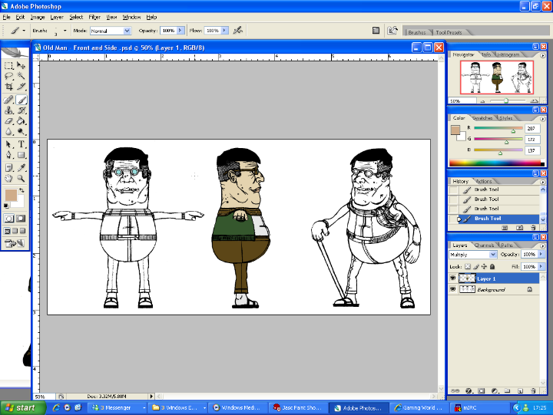
When sketching out the character in an angled pose, perspective and curved lines were included in the picture. The drawings were made as simple line art with no additional shading apart from blocking out the character’s obvious wig in black. This was done so that when it came to the colouring stage, the basic colours and shades could just be added in between the dark black outlines and details, making the process must faster. For schematic front and side views, averages of the major lines from the first sketch were used as guidelines for the heights of certain lines and objects, such as the scarf and neck line. The differences between each of the guidelines were measured and recorded down. For the front and side view blueprints, as their accuracy was vitally important, the measurements were double checked and the two new pictures were drawn with them in mind. Loose clothing like the scarf was left out on these pictures as they would not be fixed on the model. The loose parts scarf would flap in the wind and was not part of the early modelling process, they would be a cloth system added later. When both of the two drawings were compared, the most important areas of the body lined up, although unfortunately some areas, such as the lips, were slightly inconsistent. It would have been more sensible to use graph paper when creating the designs to make absolutely sure that all of the images lined up perfectly with each other.

The Shaman

The drawing style of the shaman differed significantly from the style used for “Blind Bert”. This time around, the sketches were far more realistic and detailed, with extra detail being given to shading. The anatomy was still exaggerated, as is often the case in computer games. The sizes of muscles were much larger then in real life and other details, such as the wild eyes, were made to fit the character’s profile. More care was given to adding quality shading to the sketches, to help with the colouring later on. A tutorial showing how to draw realistic heads was followed to help create the approach to the shading. This helped give the style a clearly different style to the others.

Need to talk more about Shaman and Venetian

Chris

For the high detail, realistic model (named “Chris”), photographs of my brother were taken. These included:
- Front view full body
- Side view full body
- Front view head
- Side view head
- Shot of glasses
- Shot of the teeth

Care was taken to make the photos have as little perspective as possible. The digital camera used was not of the highest quality, so some of the pictures came out slightly, or in a few cases, grossly blurred. The poses were the same as Da Vinci’s “Vitruvian Man”, the same that was done with the sketches. This pose is considered the standard when 3D modeling humans. With the full body shots, when taking photos of the upper body, the legs had more perspective on them making the legs appear shorter, and the same thing happened for taking photos of the legs with the upper body. The solution to this problem was to take pictures of both the upper and lower body and then combine the two together when it came to altering the photos into suitable guideline textures. An obvious problem appeared in the full body side view pose as there was a lot of perspective on the side view shot where the near hand was closer to the camera than the rest of the body. These problems had to be fixed before being loaded into 3D Studio Max as an out of proportion body would be useless to work from as guidelines.

2.2.2 Refining Sketches/Photos

The images were improved in Photoshop, as it is the most powerful 2D image editing software available. The tools on the program are perfectly suited to editing photos and colouring in images, so it was the obvious choice for editing the 2D images. Paint Shop Pro was used for the final touches on some of the images for changing the black outlines.

Blind Bert

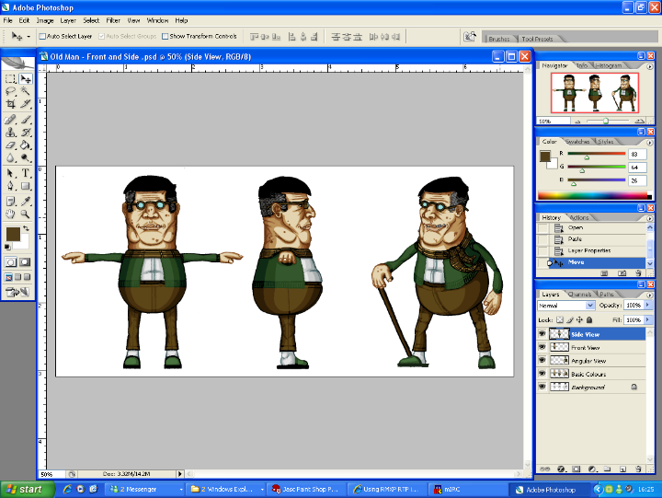
The three pictures were scanned in and had their brightness/contrast adjusted for colouring in Photoshop. “Blind Bert” was made to be wearing dull, unfashionable colours like faded green and bright brown on a cardigan, shirt, pulled up trousers and slippers. These basic colours were first applied using a graphics tablet and the multiplier tool in Photoshop. The multiplier tool allows colours to be drawn underneath the hand drawn outline. Shading was then added firstly to the head and then to the rest of the body. For each colour, there was a maximum of four shades used so that the images would not lose their cartoon like appeal. Both the 2D sketches and 3D model would have to be in a caricature style. Even with the shading added to the main colours, the black outlines caused by using the multiplier tool looked poor and amateurish, a flaw that had to be solved. The line work could have been removed all together, or re-coloured separately as possible solutions, the former being the most simplistic to test. By turning off the “Multiplier” layer in Photoshop, the black lines disappeared. The character without the line work no longer looked nearly as cartoon-like and because of this the other option of re-colouring the outlines was chosen. Overall, it was a good decision although it required more work and time. For the re-colouring the images were opened in Paint Shop Pro, a more familiar program. Using the “lasso select tool” and then the “colour replacer”, the black outlines were slowly changed into more suitable colours: darker shades of the nearest colour. A higher tolerance was set on the “colour replacer” to make sure that the whole of the black lines were being altered into the new colours. The images were “cropped” down so that no background white was left above or below the character. This meant that the sizes of the schematic pictures were the same proportions as each other. The three images were then pasted together as one texture ready to be imported into the max file.

Need to talk more about Shaman and Venetian

Chris

At first the photos were not suitable for working from in 3D Studio Max. To solve this problem, the photos had to be edited in Photoshop CS2. As this model involved photo editing and not sketching out and colouring designs, different tools were used. First off, the “distort” transform tool was used to give all of the body the correct proportions. In the side view, the hand and arm both needed a large amount of altering as they were the most out of perspective. The feet also needed heavy changing so that they faced directly forwards. The “clone stamp” tool was used for filling in the gaps made by using “distort”. Much of the arm had to be redrawn with clone stamp and to a lesser extent the “paint brush” tool. Clone stamp was the preferred tool because it copies multiple texture patterns and draws them elsewhere. The two edited photos were lined up to match so that they were ready for modelling.
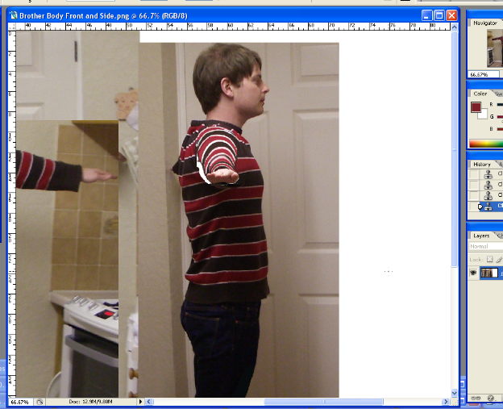
2.2.3 Modelling the Characters

As “Blind Bert” was the first of the characters to be modelled, the general process of modelling through the character has been described in full. The other models were mostly created by following the same process. The slight differences between the creation processes are described with the other characters. After researching into game character models, using Unreal 3’s game engine as a guideline, the polygon counts of characters had to be between 3,000 and 12,000 polygons. For the best results, the characters would be aimed for 6,000 or 7,000 polygons.

Blind Bert

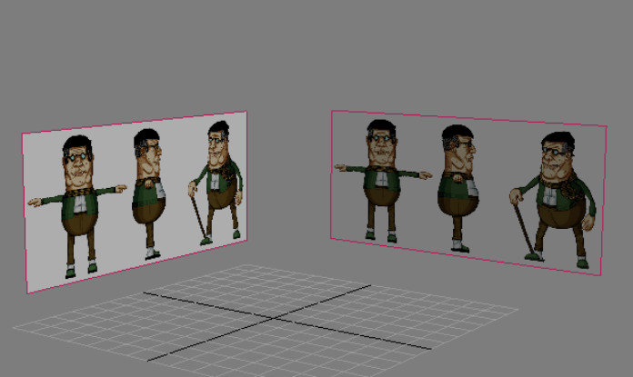
In 3D Studio Max, “M” was pressed to bring up the Material Editor and in the first texture slot, the collection of the three reference images were added by “importing bitmap”. The model would be constructed by using these pictures as guidelines. In the front and left viewports, they would be the basis for creating the general shape of the character. The reference image was 1593 pixels wide and 729 high, giving it a ratio of 2.18:1. In 3D Studio Max, the unit measurements for the file were changed to metres, as it was easier to work, and far more logical to keep objects around their correct sizes. Then a “tape measure” helper tool was created to measure out the height of a human. For this, the height chosen was 1.73m (5ft 7-8) high, which is slightly below the western world average human height. Once the height had been measured, the width was calculated by taking the 1.73m figure and multiplying it by the ratio. If this model was placed into a game map, the character would be the suitable size for going through doorways or up steps. With the right dimensions fitted to the correct scale, the texture was added to this new plane, which was renamed “Ref 1”. Another plane was cloned from this one and rotated 90 degrees and was named “Ref 2”. “Ref 1” was positioned so that in the middle of the 3D screen, the front view sketch matched up perfectly with the middle of the grid and the same was done with the other reference image so that the side view sketch matched up.

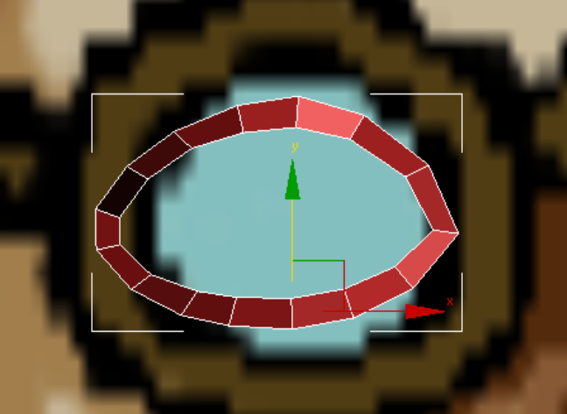
The model was started with the eye socket. A plane was created and was converted to an “editable poly”. It was renamed “Blind Bert Head”. All of the objects in the scene were given proper names so that at the end of the modelling process, it would be clear what each object was. The plane was positioned at the bottom of where the eye would be on the reference picture, which was done by guess work in the front view since the sketch had glasses on it. In the side view, by selecting the individual vertices, the plane was edited so that it fit underneath the right eye. In the front view, planes were extruded outwards by holding the shift button and dragging those outwards in the editable poly’s “edge” mode. These small planes were extruded around the entire eye and positioned accordingly. Contrasting with normal human’s faces, the eye here was made as a complete oval shape and the eyes in general were very small compared to the rest of the head. The reason for this was that small eyes, with even smaller pupils, are usually a way of depicting short sightedness in cartoons. In the side view, the eye appeared to go too far inwards into the head once the planes were lined up, but fixing this problem would come later when more of the face had been constructed.

With a new plane, the rim of half of the lips was modelled in exactly the same way. Only half of the lips were modelled to save time, as the entire right side of the character would be mirrored down the middle and welded together later on. Again, there were problems with the depth of the details in the side view picture and the lips went way too far back into the head. This problem was a regular occurrence because the sketches from imagination were bound to have some slight mistakes. Although all of the heights lined up, the depth was wrong in places. At this point it seemed like it would be very difficult to model such an odd shaped head as some of the major facial features (particularly around the chin and glands areas) would have gone further backwards into the head than the neck.

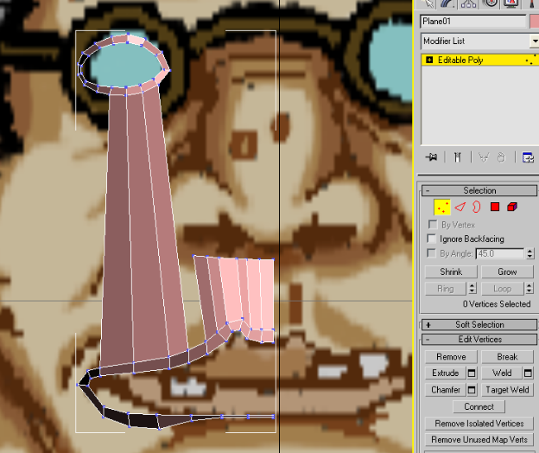
The eye and the half of the lips outlines were attached together as one mesh and then using the “bridge” tool in the edge mode were physically connected together with new planes. More planes were extruded upwards to the bottom of the nose from the lips. Next more extrusions (a process that was used many times) were made from the parts of the eye and moved to the middle of the nose, where they would be connected to the other half of the face later on. Using the “Connect” tool, these new polygons were split up into more so that the character could be more accurately represented and appear smoother. The top of the nose was made to curve around and the cheeks were rounded to make them more like those on the reference picture. The vertices were rearranged to make the contours of the face accurate for the shape of the character’s reference head. Where guess work was needed, a general knowledge of cheekbones and other areas of the head anatomy sufficed. The general face shape had been constructed at this point and the extra polygons were added to give more smoothness to the head model.

Next, the nose was extruded downwards towards the tip. Before moving onto the end of the nose, the cheeks were tweaked and extended around to the side of the head in the front viewport. The vertices on the cheek in the front view had been neglected, so they had to be moved around to be in more suitable positions to give the cheek some true roundedness. Often during the creative process, one of the two viewports was commonly neglected and had to be referred back to at a later time. More polygons were added around the sides of the head to finish off the front of the face. For connecting these new polygons to the cheek and nose, “Target Weld” for vertices was used. More were added from the top of the nose and eyes to make the brow and then the rest of the forehead up to around where the hairline would be. At this point, much of the main features of the face had been created in the front viewport. However the sides and back of the head still had to be added.

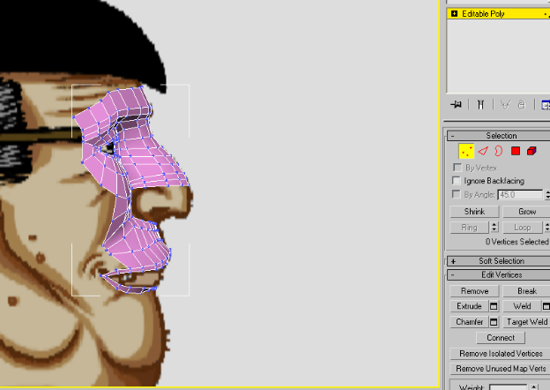
The next step was to add more faces around to the back of the head. From the far side of the eye and brow, polygons were extruded several times backwards with a slightly downward curve, ignoring the ear and hair, to the back of the head. In the top viewport, the vertices were moved so that these polygons curved around the head and to the middle back. The rest of the crown of the head, not including the hair, ears or wig was extruded from the brow and moved into the corresponding places. The scale tool was used to make the curves of the forehead more significant. To model the peak of the head, the “bridge” tool was used. With some “cutting” and “connecting” the back of the head was modelled with a suitable amount of polygons, creating as few triangles and as many quads as possible – quads are four sided polygons that are much more suitable for 3D models for smoothness and animations. Sometimes triangles can not be avoided though.
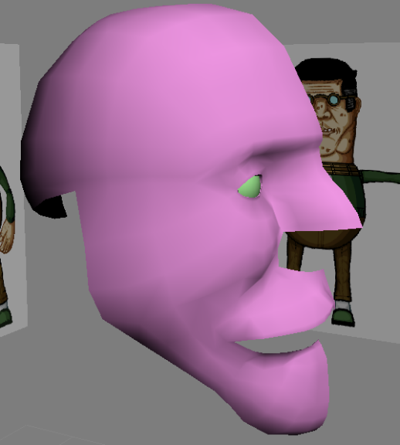
At this point, aside from a small amount of tweaking, the top of the head had been modelled. Next, from the bottom of the polygons between the top of the ear and the cheek, more were added downwards along the jaw line, and were made to fit the shape of the head. At this point it became obvious that there would be difficulties with the general shape of the head as the lips were going far too backwards into the head. On this cartoon design, the jaw line follows an unusual path as it goes inwards, around the glands, near to the mouth and down the large chin. The “bridge” and “connect” tools were again used for filling in the chin by connecting it to the bottom of the lips. The rest of the face between the cheek, mouth and jaw line was filled in with the use of “bridge”, “connect” and “cut”.

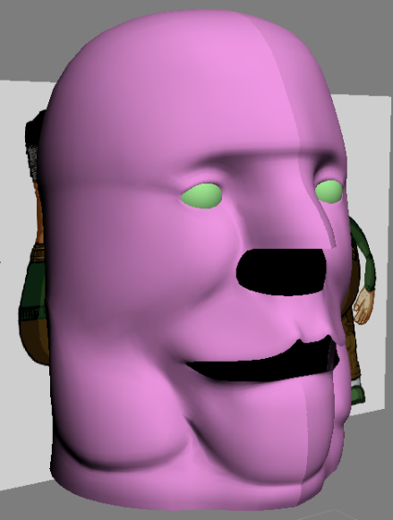
For the side of the head, polygons were added down the back of the neck. Then, just above the scarf, more were extruded horizontal around the half of the head to underneath the chin, creating the neck line. The gland was modelled next and it was made with the same amount of the polygons so that they could be easily “bridged” together. There were some difficulties with making the puffy fat the right shape on the face. This was solved by some trial and error tweaking by moving the vertices with the “Soft Selection” tool turned on. At this the other areas of the head were all tweaked by using “Soft Selection” in the vertex mode to finish off the face.

Once the puffy fat had been modelled, the only part left was the gaps between the chin, the neck and the fat. The same modelling approach as before was done once again and it was soon filled in with quads. The only problem that occurred was that the neck/scarf line was too rounded, which made the line contours of the head from the side of the chin to the scarf top curve the wrong way. This was solved by tweaking the vertices of the neck less cylindrical. A cylindrical shaped head was the aim for the character, but what can be done in 2D was a very difficult task in 3D, as in this case, the 3D work was more limited than the easily creative 2D part. The face was slightly altered for the 3D version, but it still looked very similar, which was a success.

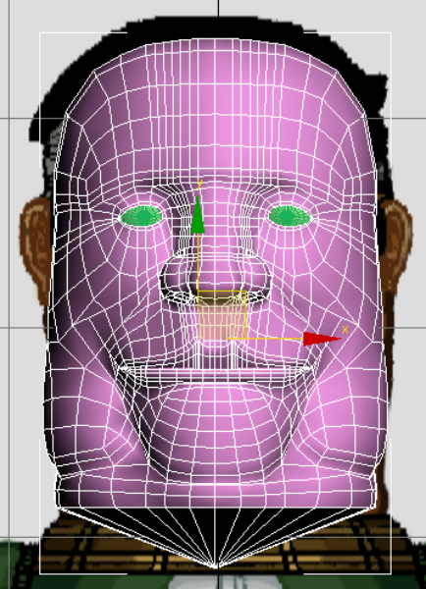
At this stage much of the head had been modelled. There were only the three most difficult and frustrating areas of the head left to do; the mouth, the tip of the nose and the dreaded ear! The first of these was the nose. Part of the nose had already been modelled. The rest of the nose was filled in with the usual tools. Extra polygons were created using the “Create Polygon” tool if there were any left over triangle gaps. The nose is a high detail area, so the new polygons were split up into a fairly large number of polygons for extra detail. Since at this point only half of the head was being modelled, the construction was quite simplistic, but it still took a fair amount of time. The main shape of the nose tip was modelled first, with the nostrils being completely ignored. The nostrils were made by moving vertices into the correct shape. They were then extruded backwards into the model a couple of times and then scaled downwards so that the passages got thinner. The mouth was modelled firstly with the top lip and then with the bottom lip and both were welded together at the back of the mouth. The mouth itself was not given much detail as it would only be seen for split seconds whilst a character talked. In this case for this project, the character would not even open his mouth, but for the sake of professionalism, the modelling of the mouth was kept in.

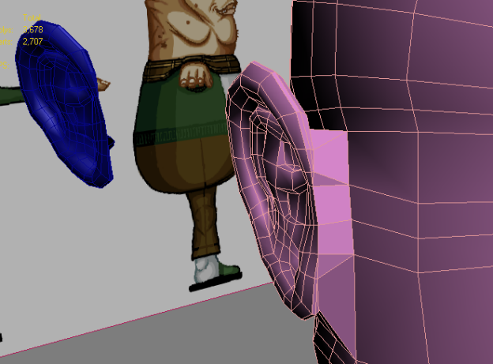
The ear was the next part of the head to the modelled. As the ear is such a detailed and complex part of the body, it was modelled separately from the main head. It was created in the same way beginning with a plane. Planes were used to draw over the outline of the ear in the left viewport. Other planes were extruded around other pronounced areas of the ear and then extruded backwards to make the dips in the ear. For the actual hole in the ear leading to the drum, a large negative extrusion was made. The rest of the ear was filled in using the usual tools. The ear took some time to model as it is such a precise and detailed area, but the actual modelling process was no longer difficult. The whole of the ear was filled in and the outside of the ear was “connected” and given more detail. The ear was also given further depth by having the lobe and outside of the ear be extruded backwards and around the back of the ear. This became essential when it came to attaching the ear to the rest, the hardest part of modelling the head. The ear was cloned and moved out of the way as a spare, just in case. Problems were expected to arise, so precautions were taken to prepare for it. At this point, the ear was “attached” to head, but not yet “welded” to the rest of the model as one element, one single mesh. In the left viewport, the polygons that the ear overlapped were deleted and new polygons were “bridged” between the deleted polygons on the main head and the polygons at the back of the ear. Some of these polygons were irregular shapes and the way that the triangles were position had to be turned around, so in the edge mode, the “turn” tool was used to fix the new polygons on the model. Attaching the ear was a long and arduous process and in the end the result did not look absolutely perfect, however, after struggling to fix it, in the end the problem did not seem large enough for any viewers to particularly mind. The ear was rotated slightly to fit suitable next to the rest of the head. However, it did not stick out nearly as much as in the front viewport’s 2D reference. This was a mistake on the 2D sketch rather than the 3D model.

The hair was created as part of the mesh as one giant clump. Since this was a cartoon based model, it seemed to be the most fitting style to go with. The “shape merge” tool was used to first cut the general shape of the hair into the head model. The geometry was chaotic at first, but “target weld” was the solution to this problem. “Shape merge” was a hair technique that was used again for the Shaman model.

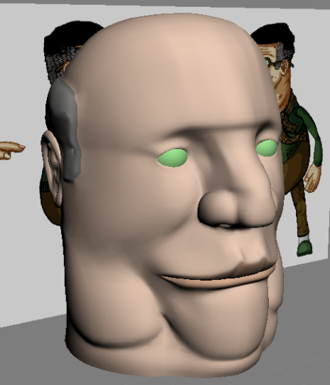
The polygons were extended down the body starting with the scarf. For this, a cylinder was created in the top viewport and the edges were the “chamfered” to give the scarf more curved edges. The new object was converted to an editable poly and then “attached” to the head model. The top face of the cylinder was deleted and then replaced with new ones that were positioned to fit the space of the head. The head was moved next to the scarf and then welded together. More extrusions were made and with soft selection it was steadily made into a crinkled scarf that curved around where the shoulders would be. From here, the main body was next. The jacket and shirt were both modelled using the same method, being careful to keep the shape of the body. With such a simple body shape, the modelling process at this stage seemed unusually simplistic and took little time. A small circular hole was left around where the arm socket would have been; ready to be modelled in later on in the process. Different basic textures colours were applied to the different clothes on the body to make the 3D model easier to understand.

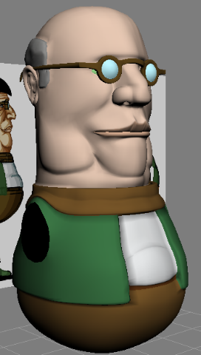
Further down the body, a slight overhang was added to the belly just above where the belt went. The rest of the body was finished off with the lower part of the body rounded off. A gap was also left for the leg. The limbs were the next to be modelled, the leg being started on. By this point, the modelling process became straightforward, but rather slow process. There were almost no difficulties with creating the limbs or the rest of the body, although at times there were polygon oddities with awkward shadows and “triangles” still being created. The majority of the faulty shadows were fixed by using the “turn” edge tool, but in some cases this too did not seem to perfect the whole model. As the leg was being extruded downwards, some of the polygons were moved through scaling and rotation to define the knee and the general shape of the trouser leg. At the very bottom of the trouser leg, “local normal” extrusions were used to give the bottom of the trousers a crisper finish. The foot and slipper were sculpted with the same tools. The shape of the foot and slipper was more obscure than other areas of the body and so took more time, but at this point the modelling process had become much easier and faster. The “collapse” tool was used to finish off the sole of the slipper and close up the model. By this point, this method for modelling characters seemed to be reasonably fast. The tools were simple to use and the body was made much faster than the head.
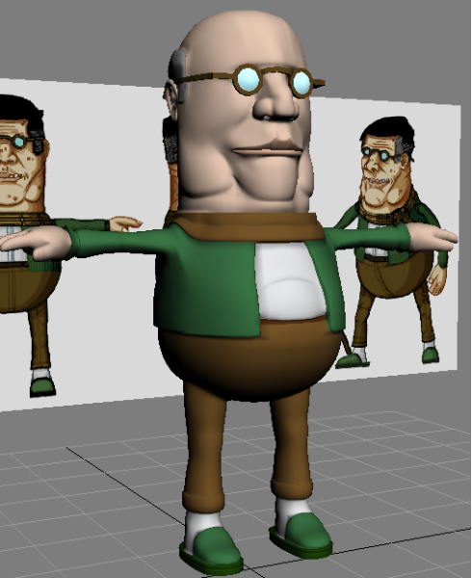
The arm sleeve was modelled with most muscle shapes were ignored. The shape of the hand was hard to create. On the 2D sketches, the hand appeared extremely large and oversized. When modelling the hand, the horizontal and vertical sizes were both scaled and experimented with. The hand was modelled as an almost normal looking hand, except for with one less finger. When looking at the whole model, the hand seemed to be way too small, so it was scaled in both axes, significantly vertically. Although this made the hand lose its normal human shape, the hands were still perfectly suitable for a cartoon design and looked more like they were in the reference pictures.

Glasses and a wig were created to finish off the modelling process. The wig model was slightly tweaked to fit around the head. At this point, it was only used as a placeholder to help give any idea of what the final model would look like by the end. The whole character model was finally mirrored and connected using a combination of “3D Snap” and “Select Weld” in the vertex mode. A small weld setting was chosen so that unintended vertices did not get attached together, such as around the lip areas. With these two objects added, the character was finally modelled. Without any extra smoothing modifiers added, the character was at 8,800 polygons and quite large for a cartoon game on a current system. If this character was modelled again, the polygon count would have been reduced to closer to the 6,000 polygon size, which would have been more reasonable.

Chris
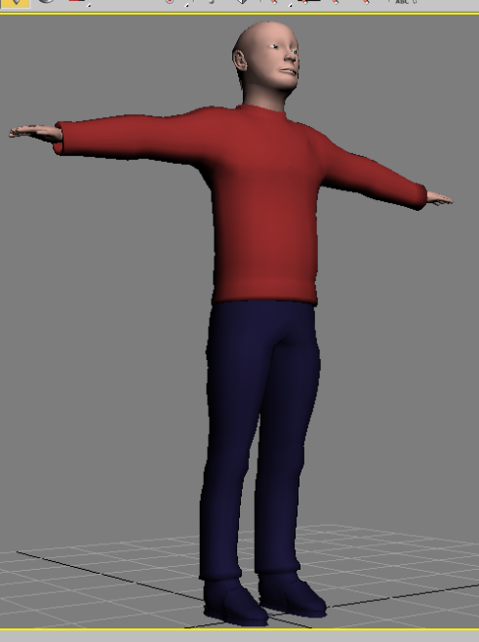
Most of the “Chris’” modelling process was the same as the others, Instead of following the sketches; the photos were the reference pictures. As far as the actual main modelling went, there were no significant differences. A higher poly count (34,000) was used to keep the realistic smoothness. This model would be more suited to a cinematic rather than a game play model, but a lower polygon version was left available. The process differed to the others at the end with the addition of realistic looking hair, with multiple strands. The reason for using this type of hair was that it looks far more realistic than just being modelled or using flat hair textures. Each individual strand could be created and also be animated using this modifier. Due to relative inexperience with the “Hair/Fur modifier” a specific tutorial was used to help. By following the idea in the tutorial, the crown of the current bald head of “Chris” was split into four new object sections; front left, front right, back left and right by selecting the polygons and clone dragging them off the original model. These new objects were moved back into position on the head by using the 3D Snap tool and were then. These had a “Hair/Fur modifier” added to each of them. This made the styling far easier than an earlier attempt done without splitting the head into parts. Two problems caused by inexperience were difficulties in making the hair longer and styling it to match the reference pictures. A tutorial (got to get the name of it) specifically walking through the process of creating proper hairstyles with the modifier provided the solutions to both of these problems. The first solution was that there are two “scale” tools for the hair, one in the “style” section and the other has the basic starting hair, one being significantly more limited than the other. Styling was done in multiple viewports, as the front and side views alone were not versatile enough to select individual strands. The actual rendered hairs did not exactly match the example display lines in the viewports either, making much of it trial and error. Hairs were moved in the side viewports around to the back of the ears and then in the dynamic rollout a simulation was run so that the hairs were weighed down onto the head, automatically putting them into the right place. Some final tweaking was done to perfect the hair.

Texturing the Characters

Blind Bert

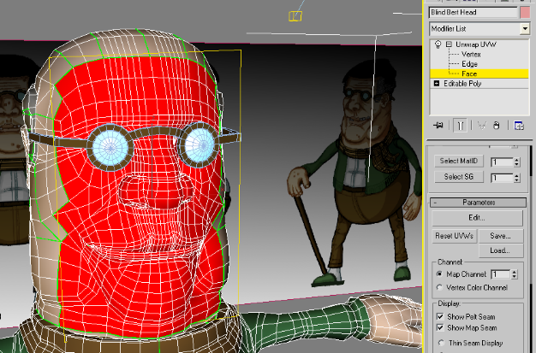
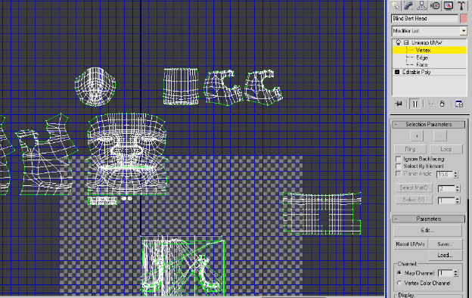
For UVW unwrapping, the main tool used was “planar unwrapping”, as it is the most simplistic and easy to use method. Other methods such as “cylindrical”, “spherical”, “box” and others are have less use than the simple “planar”, but are in most cases faster but are less simple and understandable to work on when applying textures. The results of “cylindrical unwrapping” were less precise, but they were still useful for simple limb geometry. The front of the face was the first part of the body to be unwrapped. The selection was carefully picked at areas that would be mostly facing the correct direction. The mouth and the nostrils were left out of this selection and were done separately. Some tweaking was required around the nose area, as some of the vertices and polygons overlapped with each other. This was solved by going into the “Edit UVW’s” window and manipulating the individual vertices by hand. It was a slow process, but a necessary one. Where polygons began to curve around the head and therefore in the 2D view seemed to get smaller, they were resized to make them roughly match how big they were on the 3D view. The rest of the head was unwrapped using the “planar unwrapping” method, firstly around the sides of the head, the crown and then what is left of the character’s hair. All unwrapped areas in the 2D view were separated from the rest polygons that were not yet done so that everything was clear and simple to work with.

In the same approach to the modelling process, the unwrapping began with the head and was extended down the body as more was completed. Some areas, such as the hands and ears were left until last as they were more troublesome areas. When unwrapped, the scarf was squashed horizontally in the UVW unwrap box. Shapes being squashed and stretched was a common side effect of the UVW unwrapping, but not a difficult one to fix. The major problems came from the shapes being obscure and difficult to follow. Using “planar unwrapping” and taking things slowly were things learnt from previous UVW unwrapping efforts and this time around they gave much better results when it came to the texturing. The coat, arms and shirt were the next to be unwrapped, then the trousers. Finally the slippers, hands and ears came last. These are slightly more difficult areas, but with time, care and particularly once again “planar unwrapping”, which fast became the preferred tool; these were not nearly as difficult as expected.

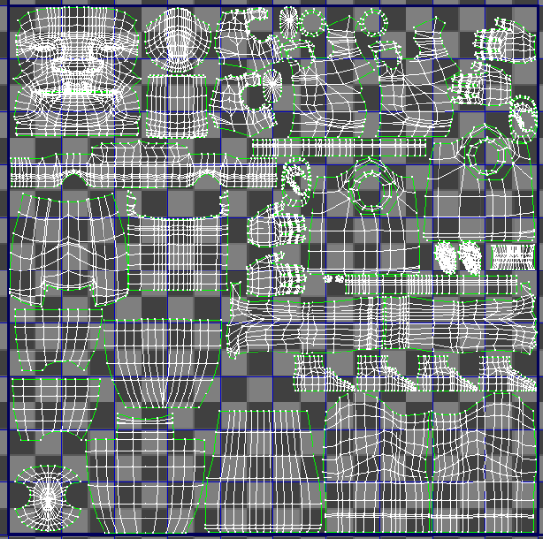
With the whole mesh, not including the separate eyes, glasses or wig, unwrapped the separate skeletons of the model were moved into the texture slot area. For this they had to be scaled down and fit into suitable sizes. The face was given the majority of the space compared to its general size, as this is always the most detailed area of a character. Small, almost insignificant areas, such as the very bottom of the trousers, or the backs of the ears were given very little texture space as they’d rarely be seen or have attention on them. The shapes were moved into the texture slot and made so that most of the space was used up. When looking back, it seems like the shapes could have been spaced more appropriately, but with a 1024x1024 texture size, there were no major problems with the textures. The UVW texture map was rendered out and was ready to be worked on for a texture in Adobe Photoshop CS2.

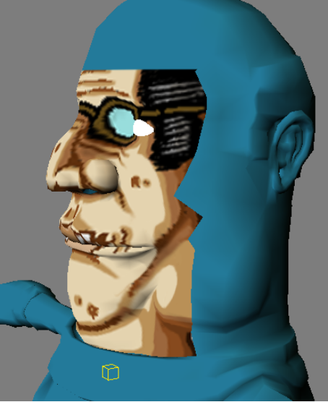
When first working on the texture, a number of layers were used. The polygon cage that was rendered out was used as a guideline layer. On a separate layer, the texture itself was being made and constantly saved in order to see the progress in 3D Studio Max. To begin with, the original 2D sketches were used to see how best to approach the cartoon-like style of the character. Using the 2D sketch style for the textured face turned out to be an absolute disaster. Apart from clear problems like the glasses being textured straight onto the character model and far too significant shades used, it did not seem like the appropriate way to go. Another option was to have very faint shading and make the 3D Max shading the “Ink and Paint” style. That is 3D Studio Max’s equivalent of 2D cell-shading. This style was next attempted, but the results were also dislikeable. The next option was to have a mixture of the two, fainter shading in Photoshop with standard shading in 3D Studio Max. This result seemed to work well and by the time the shading around the eyes replaced the old glasses, it was the definite choice.

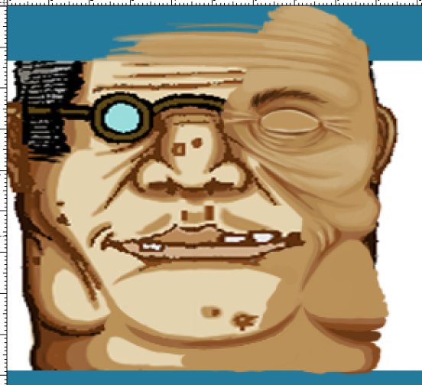
Details were added to the texture for wrinkles and sagging skin, as were the eyebrows and shades for eyelashes. Some elements of the original 2D texture had to be completely changed, such as the lips, as the model differed slightly in design to make the concept work. The lips were much longer in the UVW unwrap than they were on the original sketch, so they had to be completely re-designed. This time around, the teeth on the 2D sketch were left out as they would be modelled separately inside the mouth. To speed up the process, the texture was mirrored and copied/pasted wherever possible as the character was mostly symmetrical. However, small blemishes and details were added afterwards to make the two sides look different from each other. After texturing the front of the face, the textures were extended around the crown and sides. The textures were made to line up as they connected over texture seams, where one unwrap ended and another began. The hair lines, which also had to line up over the seams, were a slow process, but not a difficult one. Fixing up the lines so that they matched was solved by trial and error. When the head was textured, the clothes were next. The clothes had far less detailed than the head and this became a worry, since the model would look like inconsistent. The solution to this was to add a small amount of shading in areas that would usually have it and also detail in a few creases. For the scarf, this proved effective, but for the green cardigan, it still seemed starved of detail. To break up the monotony on the scarf, a couple of food stains were added. Small, hard to notice scratches of shade were added to green cardigan to give the texture a rougher look. The additions seemed to make all the difference and add a lot more to the texture. Even though it had low details, it looked like it was actually made from a clothing material. The only time difficulties occurred was with the shoes, which the unwrapping could have done with being larger to help give a finer result. To break up the brown and green monotony, a small logo was added to the slipper. The hands had nails and other details textured onto them.
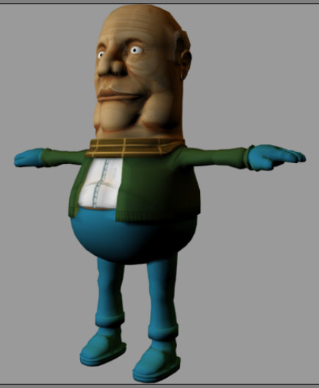
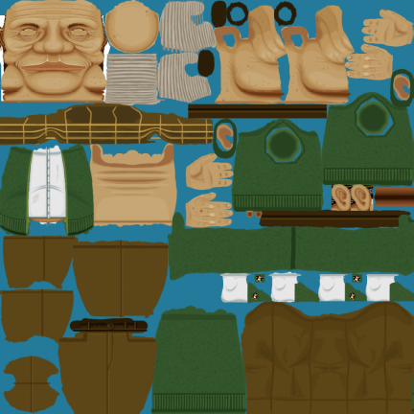

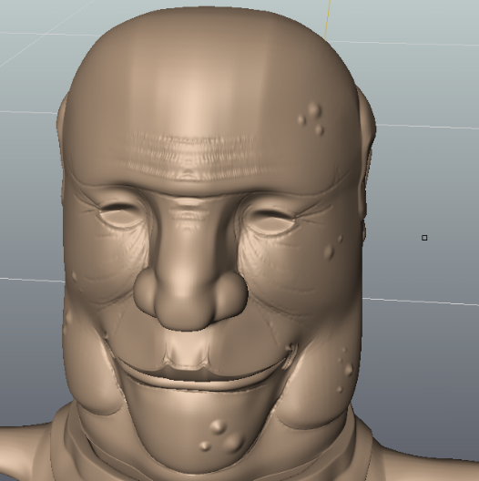
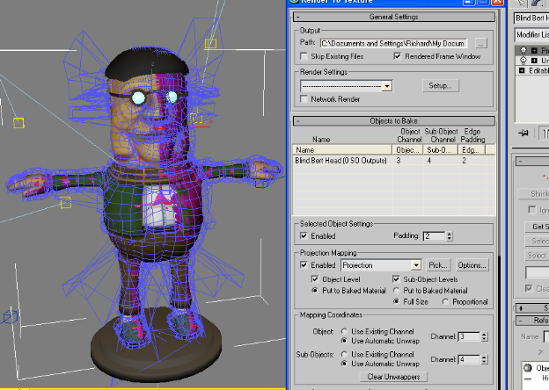
At this point, the model was looking much better than in the early stages, but there was still small extra detailed to be added. Without increasing the polygon count, more details could be added by using normal maps. Normal Maps are much like bump maps, but more advanced, but they come at the price of taking a large amount of time to create. What was needed to be done was to create a high polygon version of the character model, make further detail additions in Mudbox, set up a normal map spline cage in 3D Studio Max around the low poly and high poly meshes to get the fewest number of errors possible, render the normal map to a texture and then apply it to the low polygon mesh. It sounded very difficult and admittedly was not a walk in the park. The character model, not including separate meshes like the glasses or wig, was exported and then imported into Mudbox. Mudbox was chosen over Zbrush, a similar program, because the interface is far more simplistic and the program much easier to use. The “bulge” tool was used to create wrinkles, spots, moles and other fine points. A problem that occurred because of inexperience with the program was that the bulge tool seemed to create a tire track look in the model. Despite best efforts, this problem could not be overcome, even with the polygon count being dramatically increased. From a distance, the tire tracks were less clear, so the problem was ignored, but ultimately not fixed. The majority of the wrinkles were added around the eyes and forehead. Other areas did not have as many additions. Spots and moles were added randomly around the head in patches. The clothes had small details added to them, but not as much as the face. Mudbox turned out to be a far more efficient modelling program than 3D Studio Max for high polygon modelling. The model was exported back to 3D Studio Max where it was ready for normal mapping. To create the normal map the “Render to Texture” window was opened by pressing “0” and the details of the normal map were set up. The texture size was set to 1024 by 1024, the same size as the main texture and all of the necessities were filled in and corrected to make a projection of the high polygon mesh onto the low polygon version. A projection modifier was automatically added to the low polygon mesh where a messy cage appeared. A problem occurred when rendering out the texture, it seemed to render out over and over again, causing massive problems to the speed of the computer and eventually bringing everything to a near standstill. When trying to solve the problem, each time it was tested with a render, if the problem wasn’t solved there was a frustratingly long, slow and painstaking wait through multiple renders of the same texture. The problem was eventually solved by changing the render settings off “Active Time Segment” in a separate render window and changing it so that it rendered only the one frame. It took a while to find the solution, despite seeming like a blindingly obvious place to check first. Live and learn!

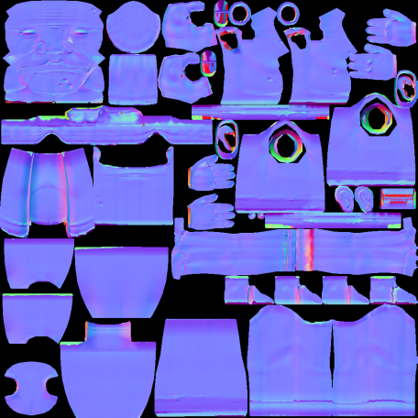
The render of the normal map had many patches of red over it. Red patches are where there are faults; faults that are caused by the normal map spline cage being overlapped by the high polygon character mesh. To solve this, the cage had to be edited. By selecting the low polygon mesh, the cage could be edited. It was first edited by “resetting” the cage to normal, as in around the low polygon mesh. It was then “pushed” outwards by a small amount so that it overlapped most of the high polygon mesh. There were still some errors and problems, but nothing unexpected. At this point, the cage had to be slowly edited vertex by vertex. The “Shading” mode proved invaluable here as it showed where the model was overlapping the cage. The “push” tool wasn’t completely accurate and can sometimes move vertices the wrong way and into confusion positions. The character’s left ear’s cage, for example, was particularly confusing. Most of these overlaps faults were solved without trouble, but some, like the ear, were extremely baffling and took a lot of time to fix. By the final normal map render there were still a few red blotches, but they appeared in out of the way places, like behind the ears, where they would not be seen. Small minor errors were fixed by editing in Photoshop and turning the red areas into blue by using the “clone stamp” and “brush” tools. Once the normal map had been created, it was added to the model’s texture as a bump map with a strength of 30%, giving the model some extra details. “Blind Bert” had been completed!

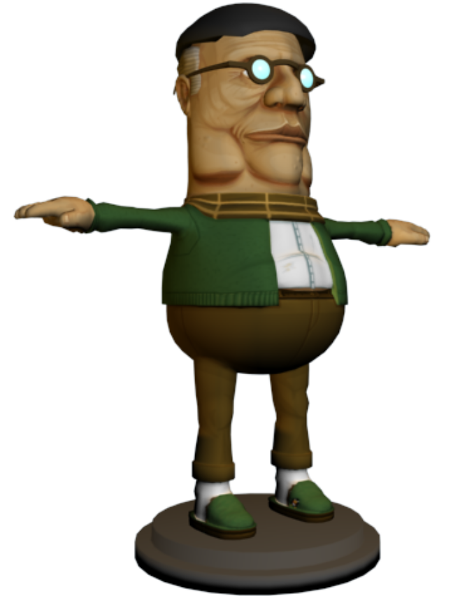

Why?
What?
Where?
When?
How?

